Item No. 10

Report to the Chairperson and Members
of the Transport and Traffic
Strategic Policy Committee

Report on trends in mode share of vehicles and people
Crossing the Canal Cordon
2006 to 2013

Dublin City Council, National Transport Authority,
Civic Offices, Dun Scèine,
Wood Quay, Harcourt Lane,
Dublin 8. Dublin 2.
February 2014

1 Introduction 1
1.1 Background to data collection 1
1.2 Definition of the Canal Cordon 1
1.3 Data sources 2
2 Data Analysis 4
2.1 Overview 4
2.2 Numbers of vehicles crossing the canal cordon by mode 6
2.3 Numbers of people crossing the canal cordon by mode 11
2.4 Percentage mode share of people crossing the Canal Cordon 13
3 Commentary on Canal Cordon Trends 15
3.1 Overall Trends 15
3.2 Public Transport Usage 15
3.3 Mode Trends 15

Introduction

Background to data collection

Since 1980, Dublin City Council (DCC) has been conducting traffic counts at 33 locations around the cordon formed by the Royal and Grand Canals. The counts are conducted during the month of November each year. Since 1997 the counts have been conducted over the period between 07:00 and 10:00.

Between 1997 and 2009, the Dublin Transportation Office (DTO) collected data from a number of sources on people crossing the Canal Cordon into Dublin’s City Centre in the morning peak between 07:00 and 10:00. The National Transport Authority (NTA) subsumed the DTO in 2009, and has continued to collate this data on an annual basis.

Combining the two sets of data enables the tracking of trends in the modes of travel that people are using to travel into the city centre. This in turn gives an indication of the effectiveness or otherwise of various transport measures and policies that have been introduced since 1997 in changing people’s travel behaviour.

Definition of the Canal Cordon

Figure 1.1 below is a map of the Canal Cordon and the 33 locations on the Cordon where data is annually collected on the movement of people in the morning peak period between 7:00 and 10:00. As the name suggests, the cordon has been chosen to ensure (as far as possible) that any person entering the City Centre from outside must pass through one of the 33 locations where the surveys were undertaken. It should be noted that the data as presented in this report refers to movements of people in one direction only (i.e. inbound into the city centre) across the various cordon points.
All 33 cordon points are on routes for general traffic into the City Centre, while 22 of the cordon points (shown in red in Figure 1.1) are on bus routes into the City. People using DART and suburban rail services to enter the City Centre cross the cordon close to cordon points 2, 16 and 31 in Figure 1.1, while those travelling on the two LUAS lines cross the cordon at points 7 and 13.

Figure 1.1 Canal Cordon – including all 33 count locations
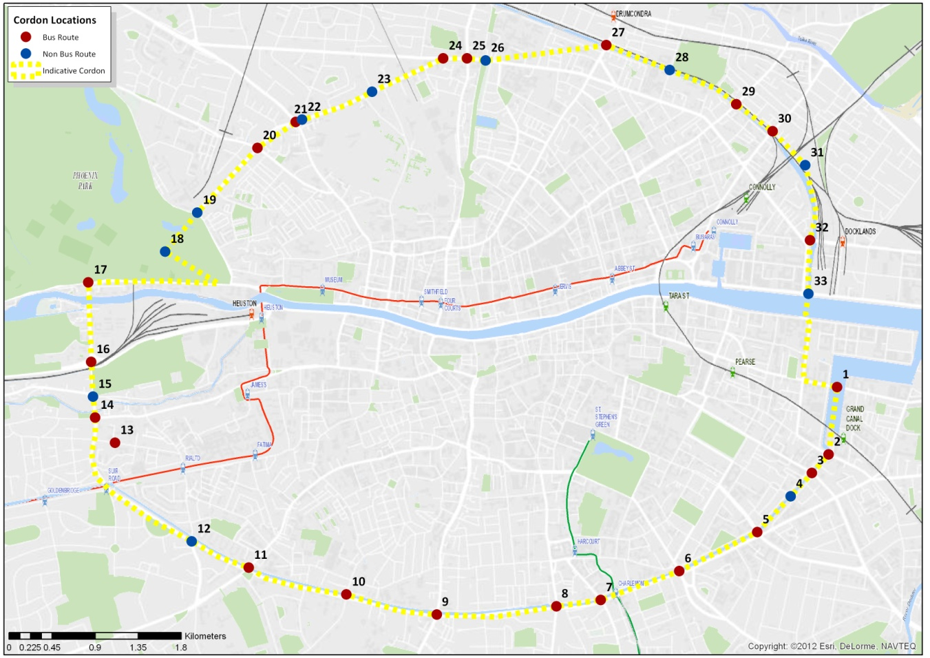

Data sources
Data as collected on the movement of people across the Canal Cordon has been assembled from a number of sources as follows:
- Dublin City Council has been undertaking surveys at the Canal Cordon on two days in November each year since 1980 and an average over the two days is reported. This survey counts pedestrians, cyclists, cars, taxis, buses, goods vehicles and motorcycles crossing the cordon points in the inbound direction in the three hour period 07:00 to 10:00.
- To complement the Dublin City Council Canal Cordon annual surveys, Dublin Bus have undertaken their own surveys annually on a single day in November (not necessarily on the same day as the Dublin City Council cordon counts). This survey counts the number of passenger on all buses (including privately operated bus services) crossing inbound over the canal cordon points. This survey is undertaken at the 22 cordon points that are on bus routes into the city (shown in red in Figure 1.1).
- Since 2012, Iarnród Éireann have undertaken a census of passenger boardings and alightings on all services passing through all stations in the national rail network in a single day. The most up to date information available is for the census carried out on November 15th 2013. Since 1997, Iarnród Éireann have undertaken a similar passenger census for services operating in the Greater Dublin Area (GDA). Analysis of the census data for services operating within the GDA enables a calculation of the numbers of rail passengers crossing the three Canal Cordon points (in the inbound direction) between 07:00 and 10:00 on the census day.
- The Railway Procurement Agency undertake an annual census of boardings and alightings at all LUAS tram stops (Red and Green lines and extensions). This census is undertaken in a single day in November, and has been undertaken every year since both LUAS lines became operational in 2004. This data enables calculation of the numbers of LUAS passengers crossing the two Canal Cordon points inbound between 07am and 10am on the census day.
By combining these four data sources, the NTA and DCC have been able to compile a comprehensive picture of the modes of travel used by people travelling across the Canal Cordon into the city in a typical morning peak period. There may be gaps in the data compiled in certain years, and some changes in the survey methodology for the Dublin City Council cordon counts have been introduced in recent years.
The introduction of LUAS also had a significant impact on the data trends. For these reasons, the analysis of trends in Chapter 2 of this report is restricted to the years 2006 to 2013. For these eight years, there is access to a consistent and continuous set of data that enables a direct comparison of mode share trends.

Data Analysis

Overview
Table 2.1 below presents the total numbers of vehicles, pedestrians and cyclists crossing the Canal Cordon inbound between 07:00 and 10:00, as surveyed in 2013 (in bold italics), and for each year between 2006 and 2013, by mode of travel.
Table 2.1 – Vehicle, cyclists and pedestrians crossing the Canal Cordon by mode of travel
Mode | 2006 | 2007 | 2008 | 2009 | 2010 | 2011 | 2012 | 2013
Bus | 1,680 | 1,740 | 1,814 | 1,704 | 1,688 | 1,539 | 1,503 | 1,539
Car | 58,664 | 58,686 | 58,897 | 58,232 | 58,047 | 55,745 | 55,343 | 54,458
Taxi | 3,825 | 4,583 | 5,079 | 4,980 | 4,809 | 4,862 | 5,277 | 5,458
Walk | 17,114 | 18,594 | 18,360 | 14,618 | 15,092 | 14,551 | 17,070 | 17,495
Cycle | 4,839 | 5,676 | 6,143 | 6,326 | 5,952 | 6,870 | 7,943 | 9,061
Goods | 2,291 | 1,445 | 1,223 | 1,087 | 993 | 1,176 | 1,099 | 1,045
Motorcycles | 2,395 | 2,429 | 2,375 | 2,060 | 1,656 | 1,485 | 1,425 | 1,423
Total | 90,808 | 93,153 | 93,891 | 89,007 | 88,237 | 86,228 | 89,660 | 90,479
The data is displayed in graphical format in Figure 2.1.
Section 2.2 provides an analysis of this data by mode of travel, identifying the trends in the number of vehicles, pedestrians and cyclists crossing the canal cordon during the peak morning period from 07:00 to 10:00.
In the later section 2.3, this analysis is supplemented with additional public transport data to provide a full picture of the travel trends in person terms across the canal cordon.

Figure 2.1 – Vehicles, cyclists and pedestrians crossing the canal cordon by mode of travel 2006 to 2013

Numbers of vehicles,cyclists and pedestrians crossing the canal cordon by mode
Buses
Between 2012 and 2013, there was an increase in the number of buses crossing the cordon from 1,503 buses in 2012 to 1,539 in 2013, an increase of 2.4%. Within this change, there was no significant change in the number of Dublin Buses crossing the canal, while the number of private buses increased by 9.2%.
In the period eight year period, 2006 to 2013, the total number of all buses crossing the cordon has decreased by 8.4%. Over this same interval, the number of Dublin Bus vehicles has decreased by 15.2% while the number of private buses has increased by 18.1%.

Cars and Taxis
Between 2012 and 2013, there was a decrease in the number of cars and taxis crossing the cordon from 60,620 vehicles in 2012 to 59,916 in 2013, a decrease of 1.16%.
Over the eight year period between 2006 and 2013, the peak year for cars and taxis crossing the canal cordon was in 2008 registering 63,976 vehicles. The 2013 figure represents a decrease of 6.35% from this peak.

Taxis
Taxis made up 6.1% of all cars crossing the canal cordon in 2006. This increased to 9.1% in 2013. Between 2006 and 2013 the total number of taxis crossing the cordon increased by 42%. From 2012 to 2013 there was an increase of 3.4%.

Pedestrians
The number of pedestrians crossing the canal cordon increased from 17,070 people in 2012 to 17,495 people in 2013, an increase of 2.49%.
Between 2006 and 2013, the peak year was 2007 with the volume of pedestrians registered at 18,594 in that year. The volume of pedestrians crossing the canal cordon in 2013 is 5.9% below that peak.

Cyclists
There was an increase of 14.1% in the number of cyclists crossing the canal cordon between 2012 and 2013, with 9,061 cyclists counted in 2013 compared to 7,943 cyclists in 2012.
Between 2006 and 2013 the volume of cyclists crossing the canal cordon during the morning peak period has increased by 87.2%.

Goods Vehicles
The number of goods vehicles crossing the cordon in the peak morning period declined by 4.9% between 2012 and 2013, down from 1,176 vehicles in 2012 to 1,099 vehicles in 2013.
Over the longer period between 2006 and 2013, the number of goods vehicles crossing the canal cordon during the morning peak decreased by 54.4%.

Motor Cyclists
There was a minor decrease of 0.1% in the number of motor cyclists crossing the canal cordon between 2012 and 2013, with 1,425 motor cyclists recorded in 2012 and 1,423 counted in 2013.
From 2006 to 2013 the volume of motor cyclists crossing the canal cordon during the morning peak period decreased by 40.5%.

Numbers of people crossing the canal cordon by mode
Using the data obtained from the public transport surveys, Table 2.2 gives the total numbers of people crossing the Canal Cordon inbound between 07:00 and 10:00 for 2013 (in bold italics), and for each year between 2006 and 2013 broken down by mode of travel.
Table 2.2 Numbers of People crossing the Canal Cordon by mode of travel
Mode | 2006 | 2007 | 2008 | 2009 | 2010 | 2011 | 2012 | 2013
Bus | 59,874 | 57,201 | 60,438 | 56,168 | 50,420 | 54,251 | 52,007 | 56,177
Rail | 33,534 | 35,692 | 32,324 | 25,723 | 23,580 | 22,932 | 23,999 | 24,969
LUAS | 9,029 | 9,171 | 9,242 | 8,776 | 9,111 | 9,949 | 10,014 | 10,835
All Public Transport | 102,437 | 102,064 | 102,004 | 90,667 | 83,111 | 87,132 | 86,047 | 91,981
Car | 76,850 | 71,597 | 67,732 | 71,043 | 71,978 | 69,681 | 68,626 | 68,072
Taxi | 1,453 | 2,154 | 1,930 | 2,739 | 2,260 | 2,674 | 3,271 | 3,111
Walk | 17,114 | 18,594 | 18,360 | 14,618 | 15,092 | 14,551 | 17,070 | 17,495
Cycle | 4,839 | 5,676 | 6,143 | 6,326 | 5,952 | 6,870 | 7,943 | 9,061
Goods | 2,291 | 1,445 | 1,223 | 1,087 | 993 | 1,176 | 1,099 | 1,045
Motorcycles | 2,395 | 2,429 | 2,375 | 2,060 | 1,656 | 1,485 | 1,425 | 1,423
Total Person Trips | 207,379 | 203,959 | 199,767 | 188,540 | 181,042 | 183,569 | 185,481 | 192,188
The data is displayed in graphical format in Figure 2.2.

Figure 2.2 – Mode share of people crossing the canal cordon 2006 to 2013

Percentage mode share of people crossing the Canal Cordon
Table 2.3 gives the percentage mode share for all modes of travel used by people crossing the Canal Cordon inbound between 07:00 and 10:00 for the years 2006 to 2013.

Table 2.3 – Mode share of people crossing the canal cordon 2006 to 2013 –
Mode | 2006 | 2007 | 2008 | 2009 | 2010 | 2011 | 2012 | 2013
Bus | 28.87% | 28.05% | 30.25% | 29.79% | 27.85% | 29.55% | 28.04% |  |  | 29.23%
Rail | 16.17% | 17.50% | 16.18% | 13.64% | 13.02% | 12.49% | 12.94% |  | 12.99%
LUAS | 4.35% | 4.50% | 4.63% | 4.65% | 5.03% | 5.42% | 5.41% |  | 5.67%
All Public Transport | 49.40% | 50.04% | 51.06% | 48.09% | 45.91% | 47.47% | 46.39% |  | 47.86%
Car | 37.06% | 35.10% | 33.91% | 37.68% | 39.76% | 37.96% | 37.00% |  | 35.6%
Taxi | 0.70% | 1.06% | 0.97% | 1.45% | 1.25% | 1.46% | 1.76% |  | 1.63%
Walk | 8.25% | 9.12% | 9.19% | 7.75% | 8.34% | 7.93% | 9.20% |  | 9.15%
Cycle | 2.33% | 2.78% | 3.08% | 3.36% | 3.29% | 3.74% | 4.28% |  | 4.74%
Goods | 1.10% | 0.71% | 0.61% | 0.58% | 0.55% | 0.64% | 0.59% |  | 0.55%
Motorcycles | 1.15% | 1.19% | 1.19% | 1.09% | 0.91% | 0.81% | 0.77% |  | 0.74%
Total Person Trips | 100% | 100% | 100% | 100% | 100% | 100% | 100% |  | 100%

The trend is graphed in Figure 2.3 below.

Figure 2.3 – Mode share of people crossing the canal cordon 2006 to 2013

Commentary on Canal Cordon Trends
From an analysis of the data presented in chapter 2 above, the following trends are apparent:

Overall Trends
As shown in Table 2.3 and Figure 2.3, the total number of people crossing the Canal Cordon in the morning peak period (7:00 to 10:00) increased by 3.6% between 2012 and 2013, from 185,481 person trips in 2012 to 192,188 person trips in 2013.
Over the longer period from 2006 to 2013, total person trips has decreased by 7.3% overall, down from a peak of 207,379 in 2006.

Public Transport Usage
Between 2012 and 2013, there was an increase of 6.9% in the number of public transport users crossing the cordon between 7:00 and 10:00, up from 86,047 users in 2012 to 91,981 users in 2013.
All three modes of public transport – bus, rail and Luas – showed increases from 2012 numbers, with bus and Luas showing increases above 8% and rail showing an increase of 4%. Bus had the largest number of additional passengers, 4,170 additional users.
While continuing the trend of the last three years of increasing public transport passenger numbers, the number of passengers is still 10.2% below the equivalent 2006 numbers.

Mode Trends

A summary of the key changes in travel across the Canal Cordon set out in section 2 is described below:

In percentage terms, the mode share for bus travel across the canal cordon in 2013 is 29.38%, down 0.87% from the peak 30.25% mode share for bus in 2008.

Comparatively, the mode share for rail across the canal cordon in 2013 is down over 4.5% (to 12.99%) from a peak of 17.5% mode share in 2007.

Cycling usage has continued its steady trend of increasing usage, and now represents a mode share of 4.74%.
      - Car usage (excluding taxis) declined by 0.81% in 2013.
      - Inter-City Rail, Suburban rail and DART has lost a significant share of travel into Dublin city centre, with a drop of 3.2% in mode share between 2006 and 2013. However, the recent trend has changed, with a 0.5% increase in Rail mode share between 2011 and 2013.
      - Bus mode share increased by 1.2% between 2012 and 2013, giving a mode share of 29.23% in 2013. Bus carried over 56,000 passengers into the city in 2013, representing 61% of all public transport trips in the morning peak.

The number of cyclists entering Dublin City has increased by a significant 87% over the period 2006 to 2013. This significant increase reflects a number of measures introduced in the past seven years to promote cycling in the city – including the Dublinbikes bike rental scheme, the provision of cycle lanes, public awareness campaigns to promote cycling and the introduction of the 30kph city centre speed limit. However, the trend in Dublin is also part of general nationwide trend of increased use of cycling in recent years – with the recent Census figures showing a national increase of 10% in people travelling to work by bicycle between 2006 and 2011.

The walking mode share alternately increased and decreased each year from 2007 to 2013. Increases in the numbers of people walking past the Canal Cordon have been recorded each year since 2010.

The number of motorcyclists entering the city across the Canal Cordon has reduced significantly (by 40%) in the last seven years.

In line with the reduced number of people crossing the Canal Cordon in 2013 than was the case in 2006, the number of people accessing the city by car had decreased by almost 11% between 2006 and 2013. There has been a decrease in the number of people crossing the Canal Cordon by Car since 2010, and in the mode share.

The number of people travelling in taxis across the Canal Cordon has more than doubled over the past seven years, and the taxi mode share (though small in overall terms) has more than doubled. This reflects the large increase in the availability of taxis in recent years.

